Assignment 2 – HTML Basics.__

➢ 1. Create a basic webpage titled “My First Web Page”. Inside the <body>, display your full name as a main heading (<h1>) and write a short introduction paragraph about yourself ?

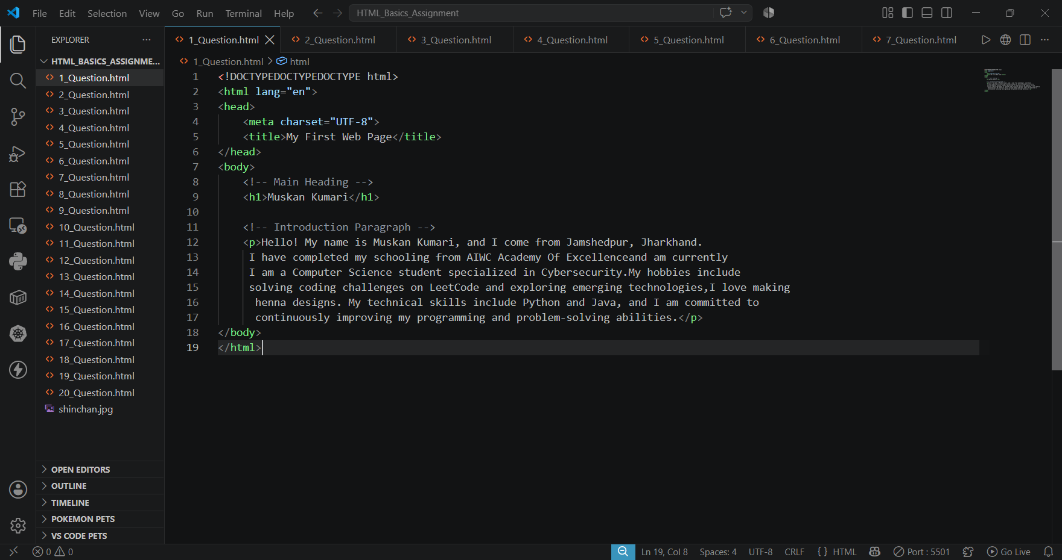

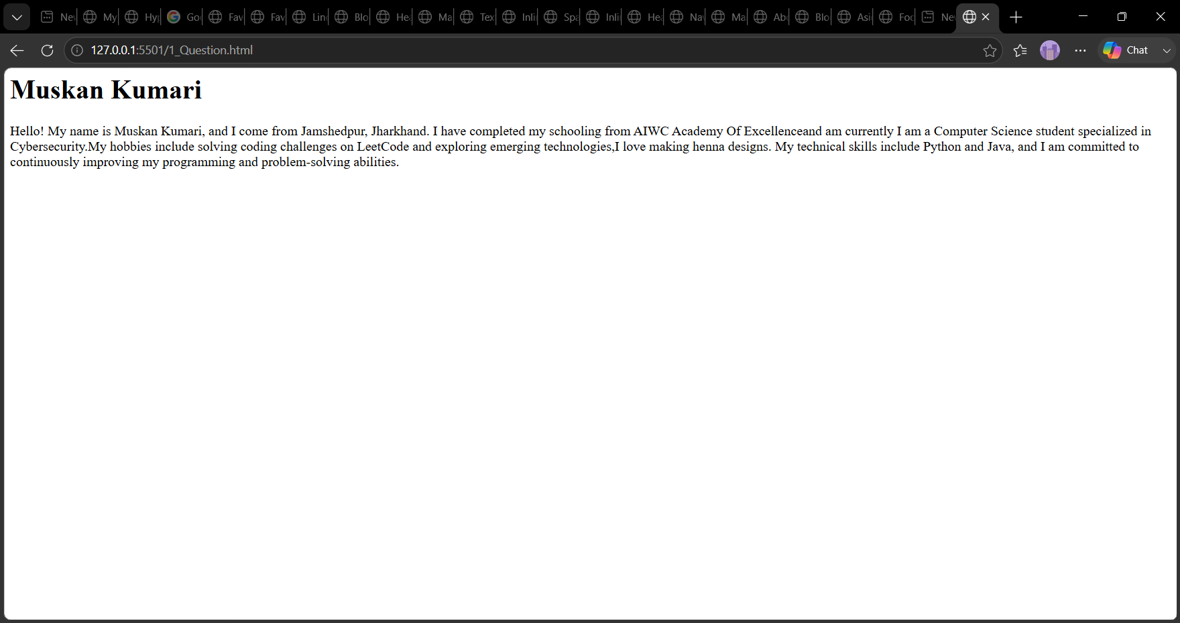

➢ 2. Add a hyperlink (<a>) to Google with suitable link text. Make sure the link opens in a new tab ?

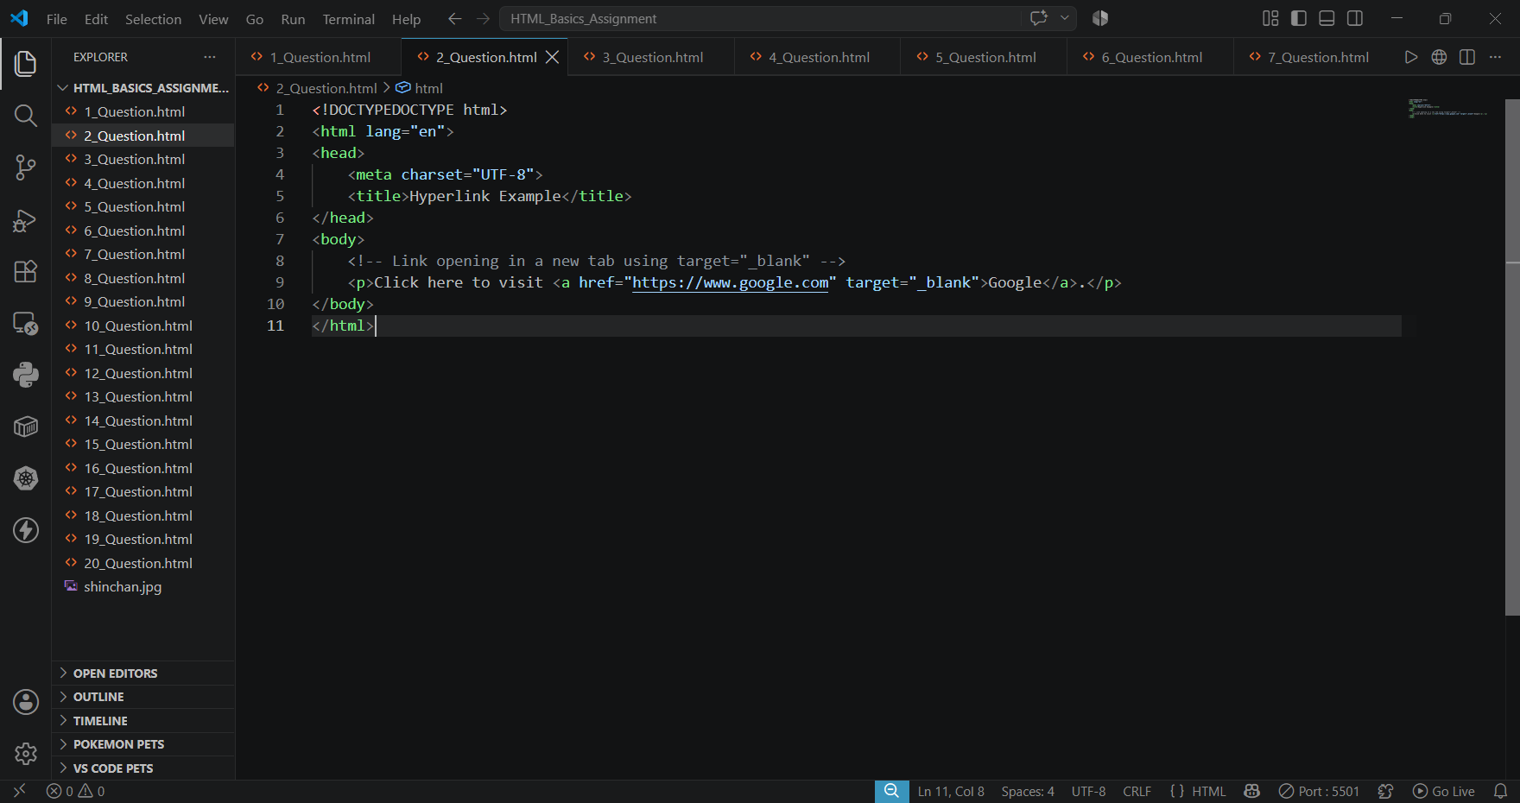

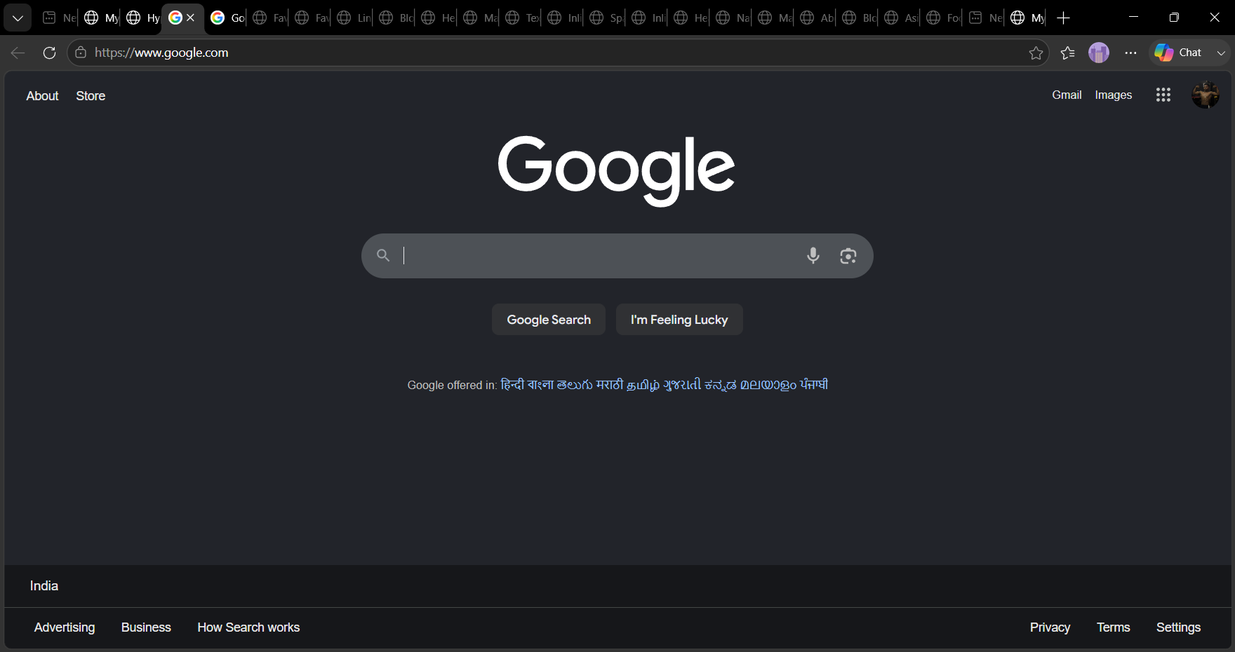

➢3. Insert an image (<img>) of your favorite cartoon or animated character ?
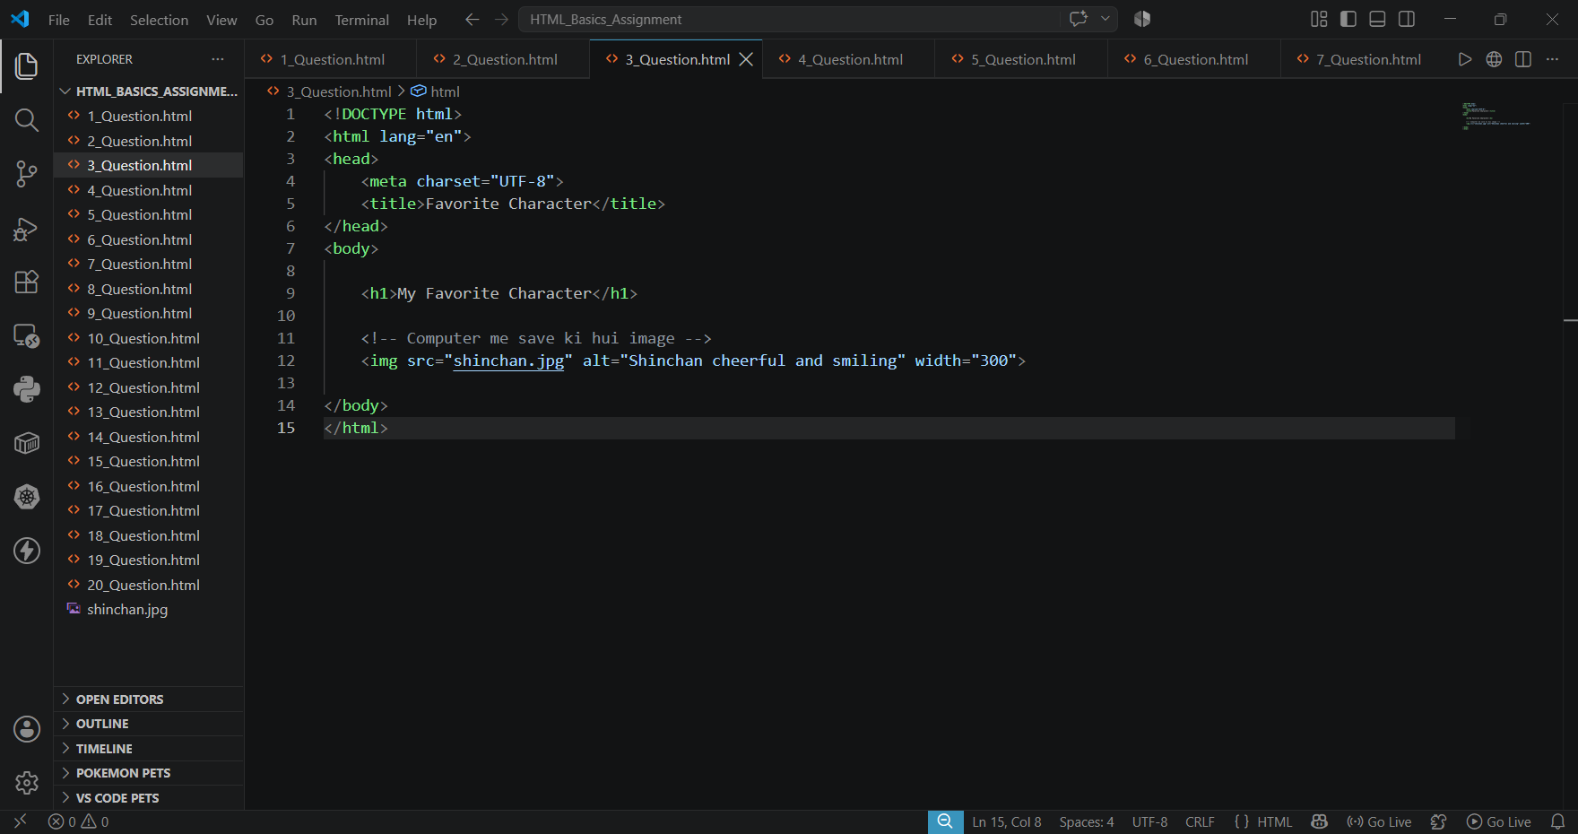

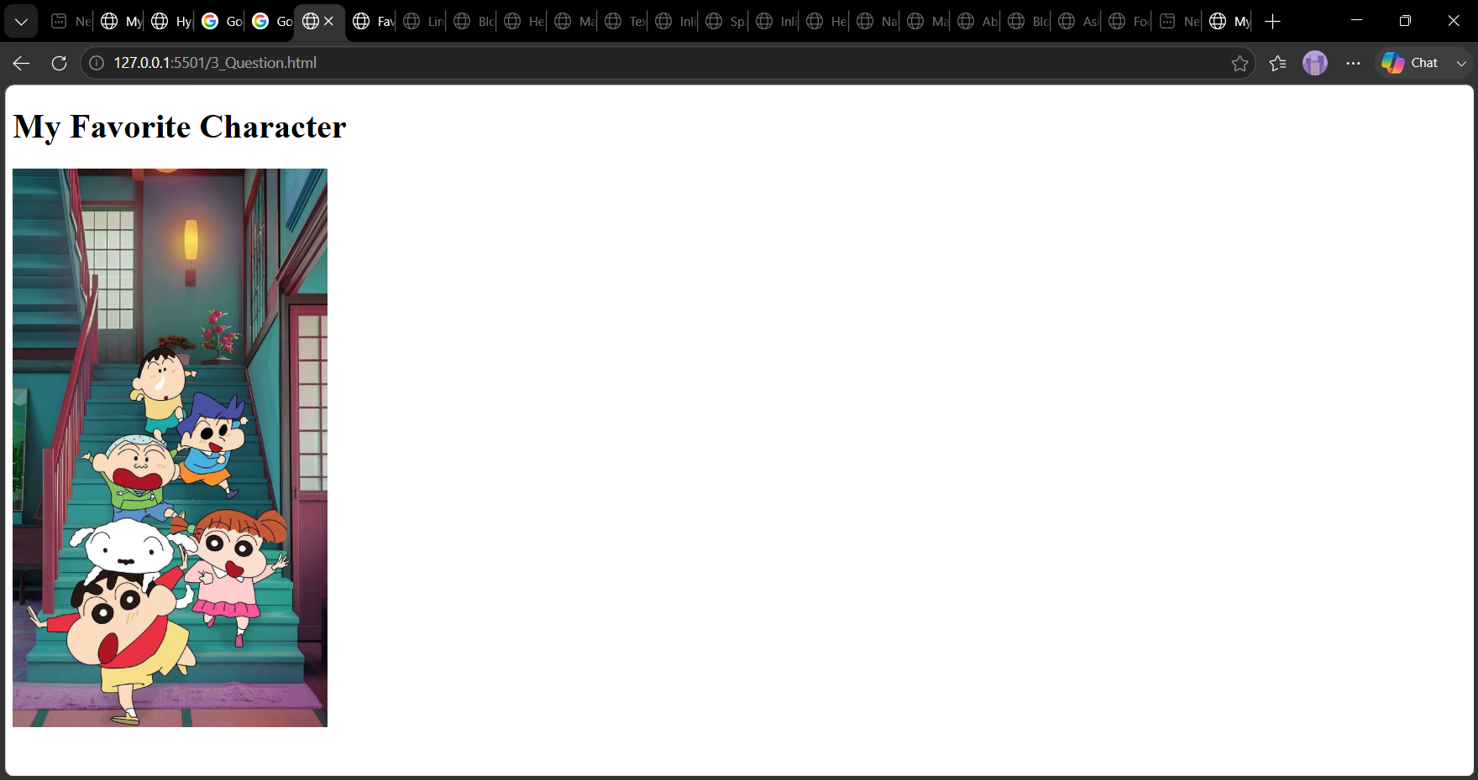

➢4. Write a paragraph describing your favorite hobby. Use <strong> to make one important word bold and <em> to make another italic ?
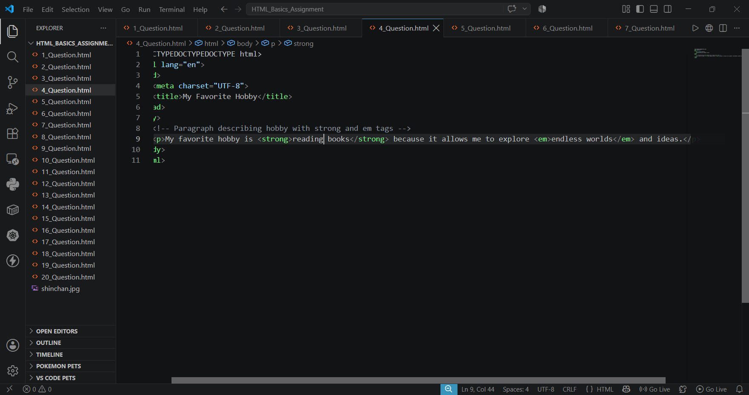

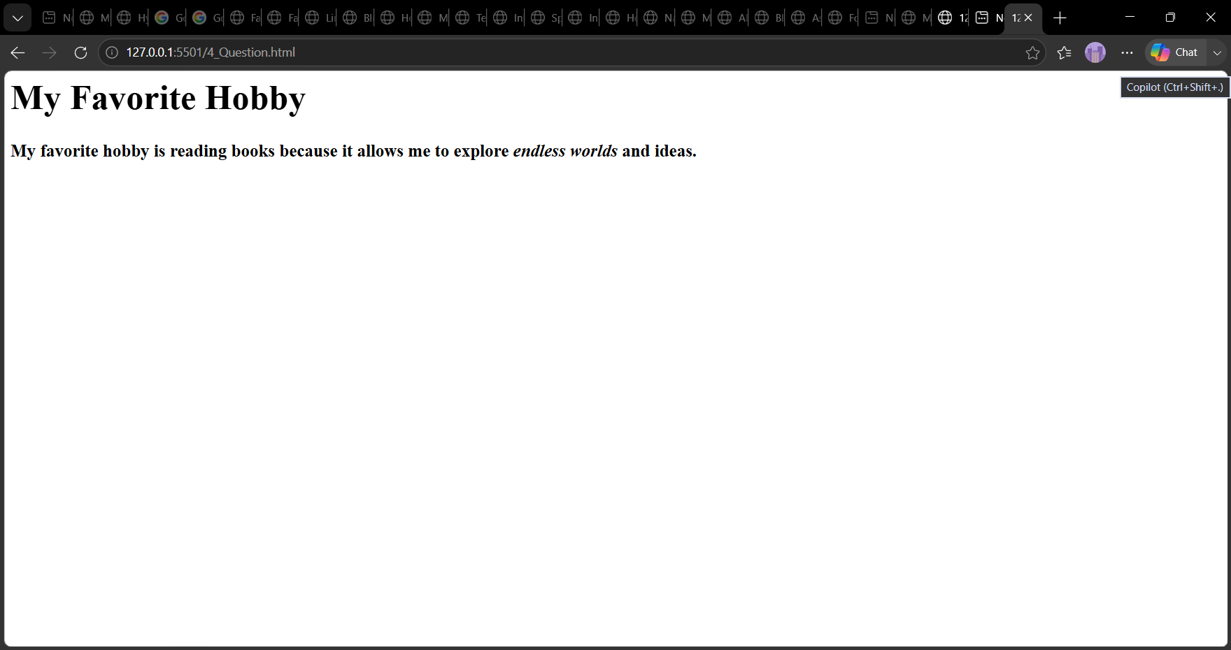

➢ 5. Create a paragraph with two sentences, but separate them using a line break (<br>) tag ?
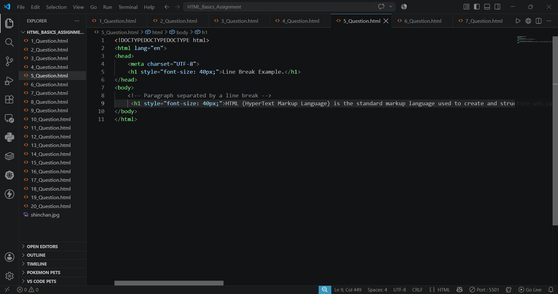

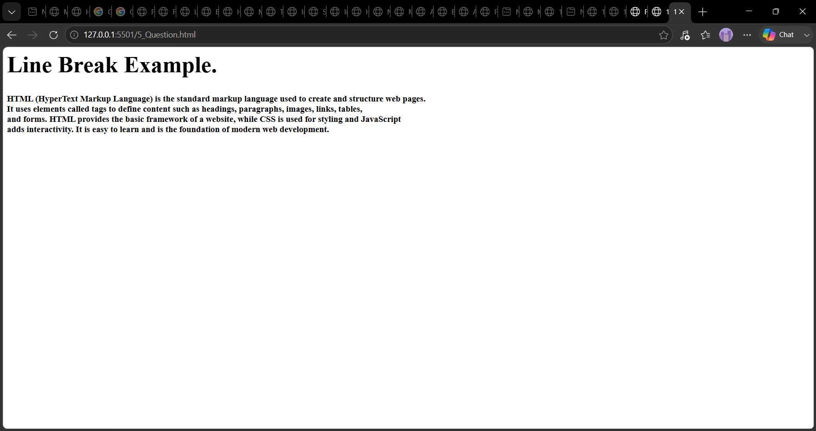

➢6. Use the <blockquote> tag to display a meaningful quote and mention the author’s name using <cite> ?
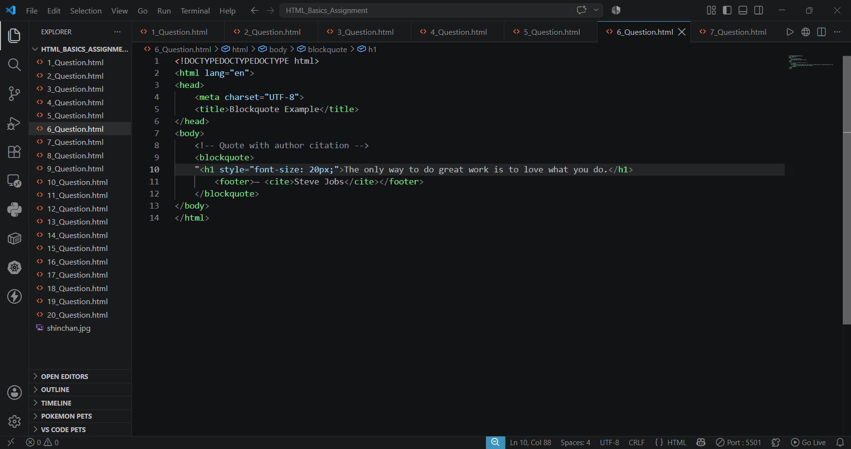

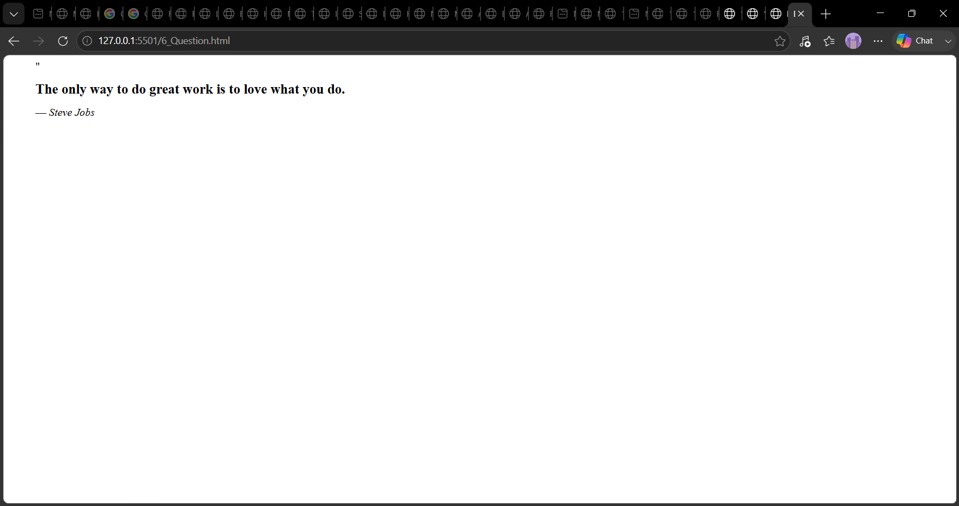

➢7. Demonstrate different heading levels by adding:

● <h1> for your name,

● <h2> for your role (student/profession),

● <h3> for your hobbies or interests.
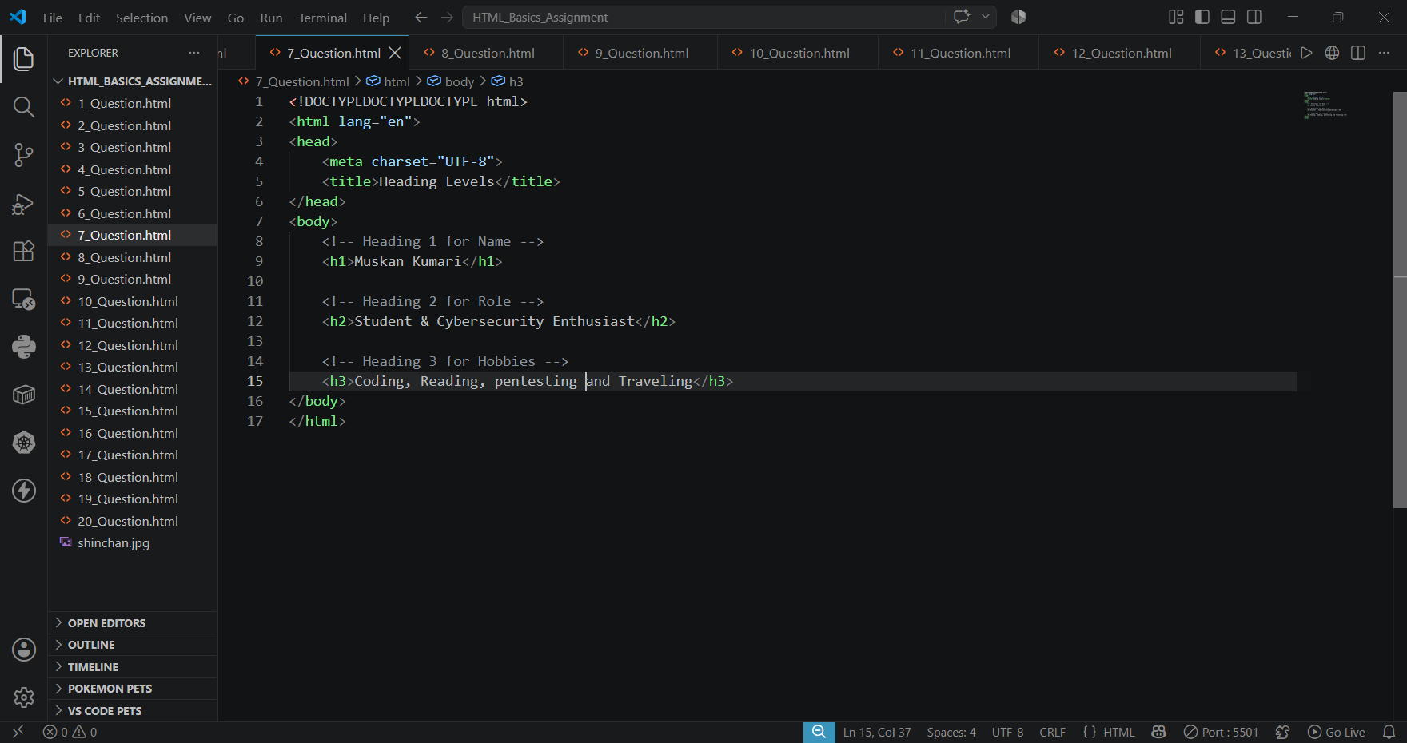

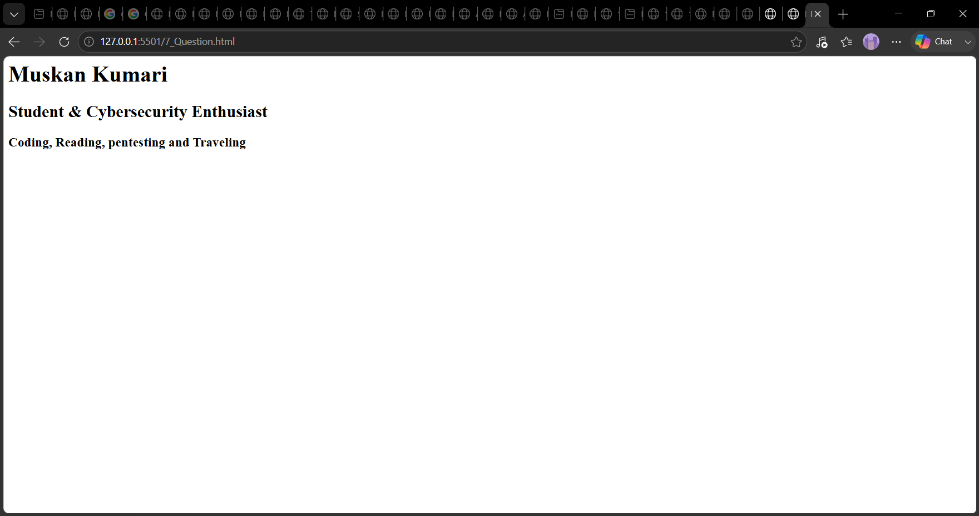

➢8. Write a paragraph containing:

● A highlighted word using <mark>

● A small note at the end using <small> (e.g., “Updated recently”).
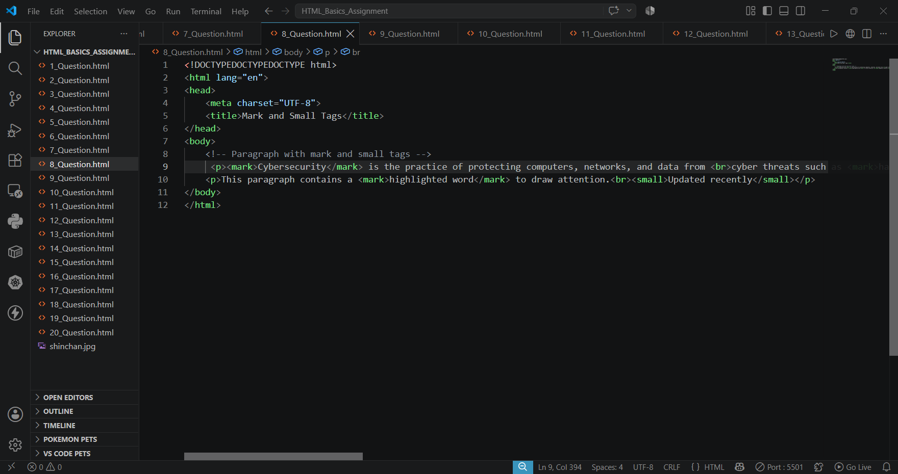

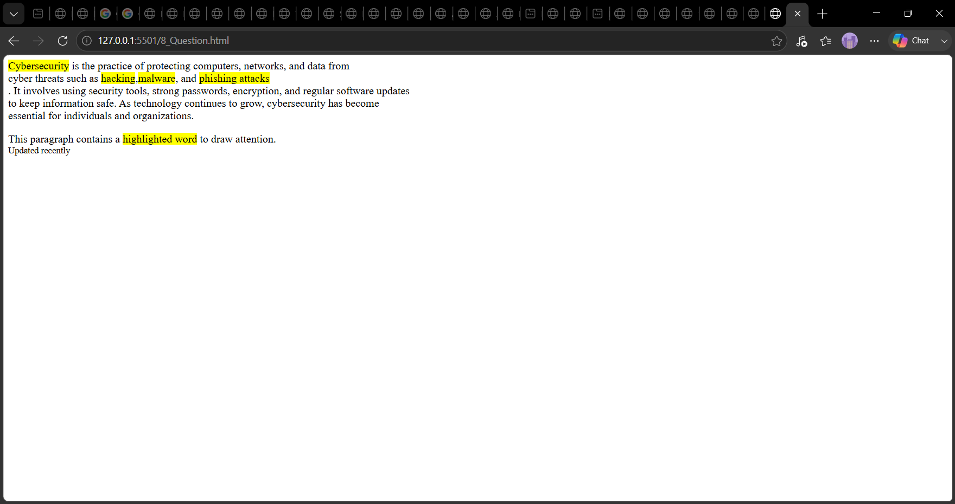

➢9. Create a paragraph that uses both <strong> and <em> to emphasize different parts of a sentence.
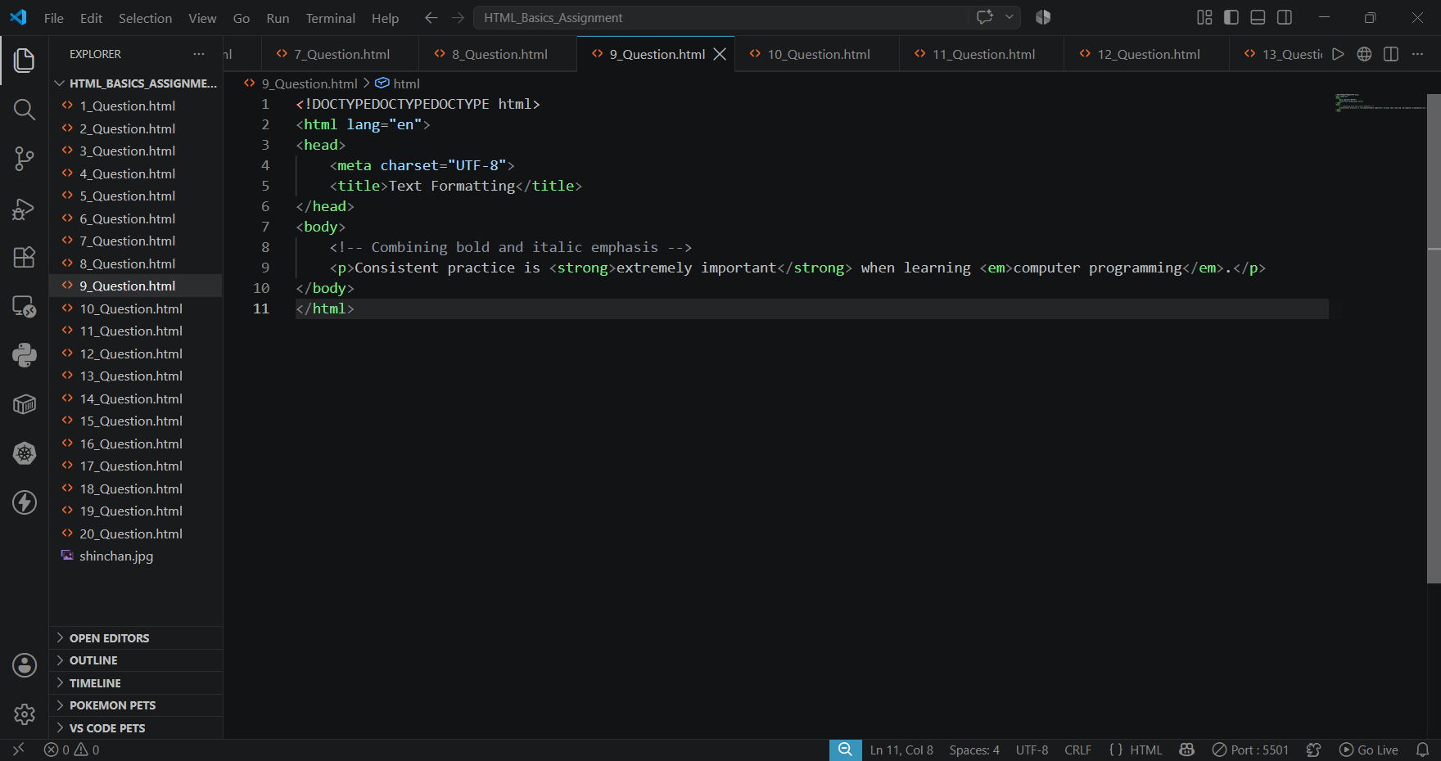

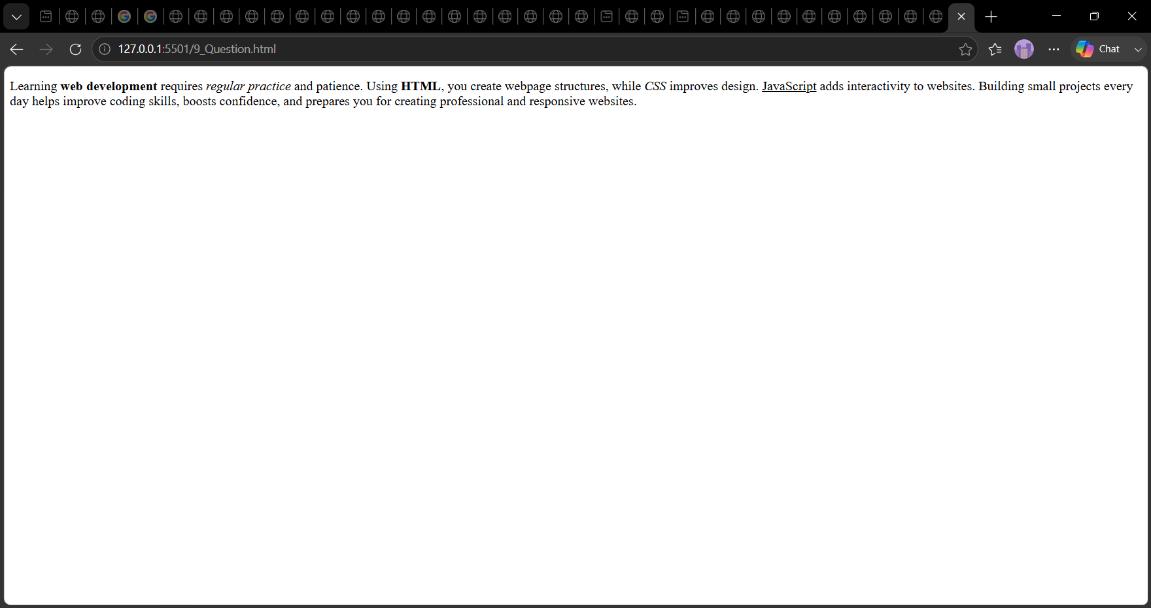

➢ Display a line of inline code inside a paragraph using the <code> tag. Example: show how to print “Hello World” in JavaScript ?
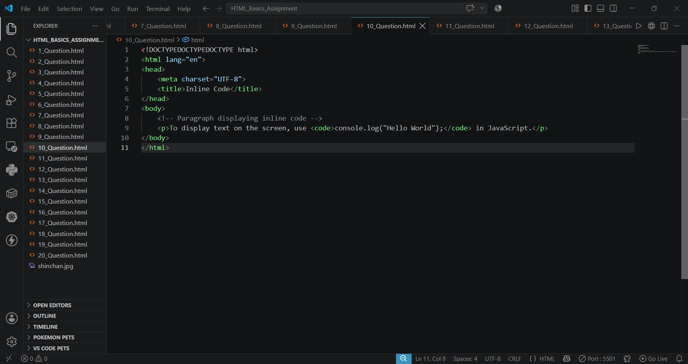

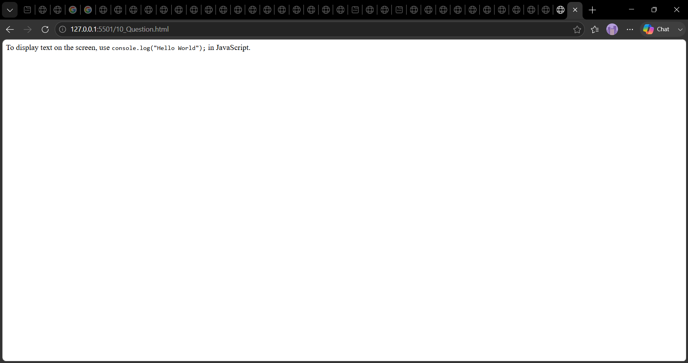

➢11. Write a paragraph that contains three <span> elements — use them to highlight or label different parts of the text (you can imagine colors or meanings) ?
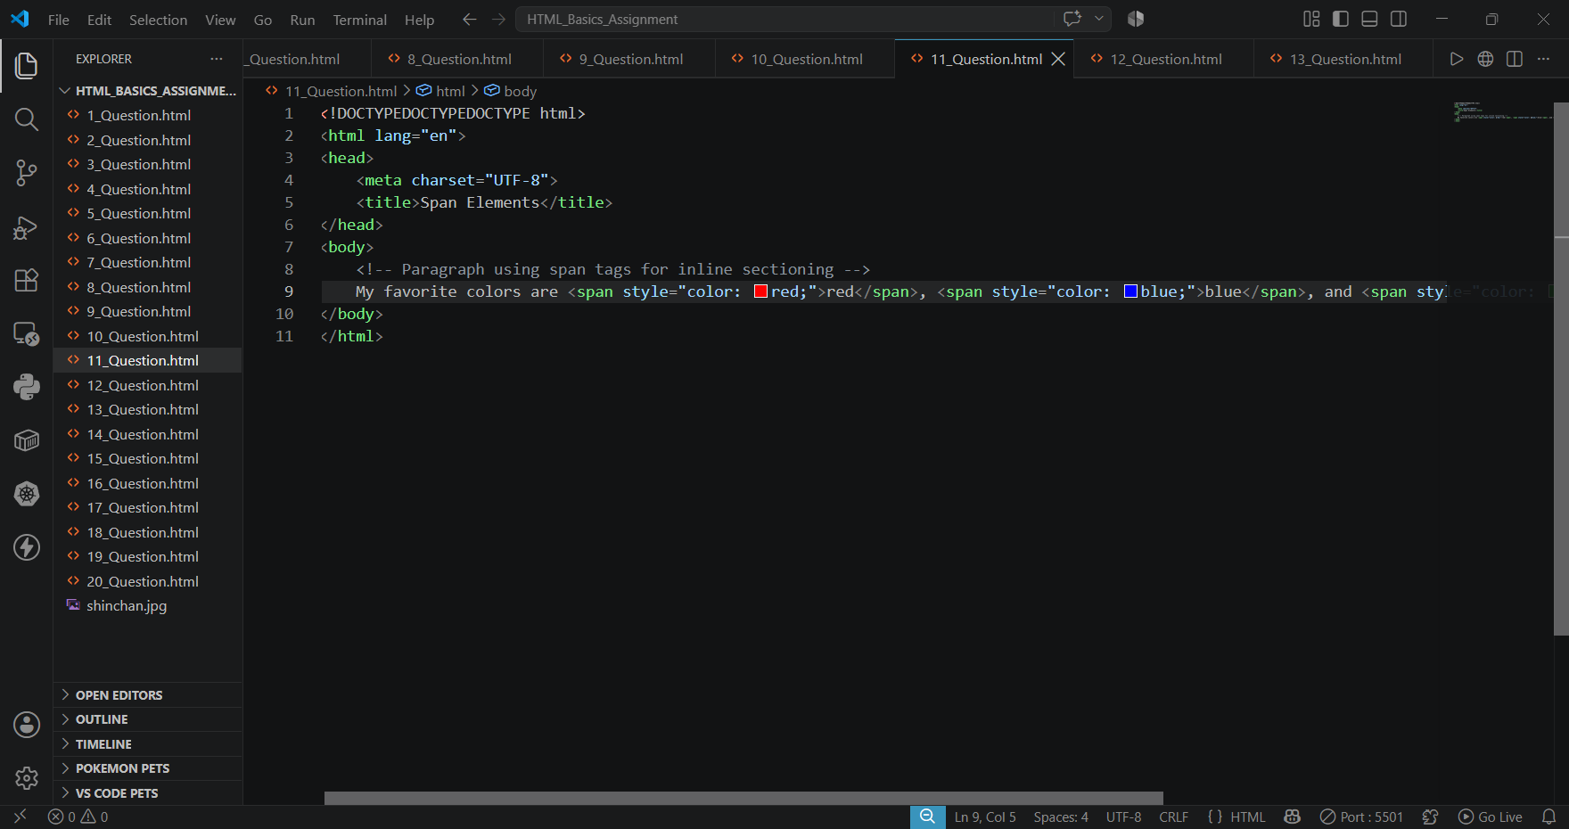

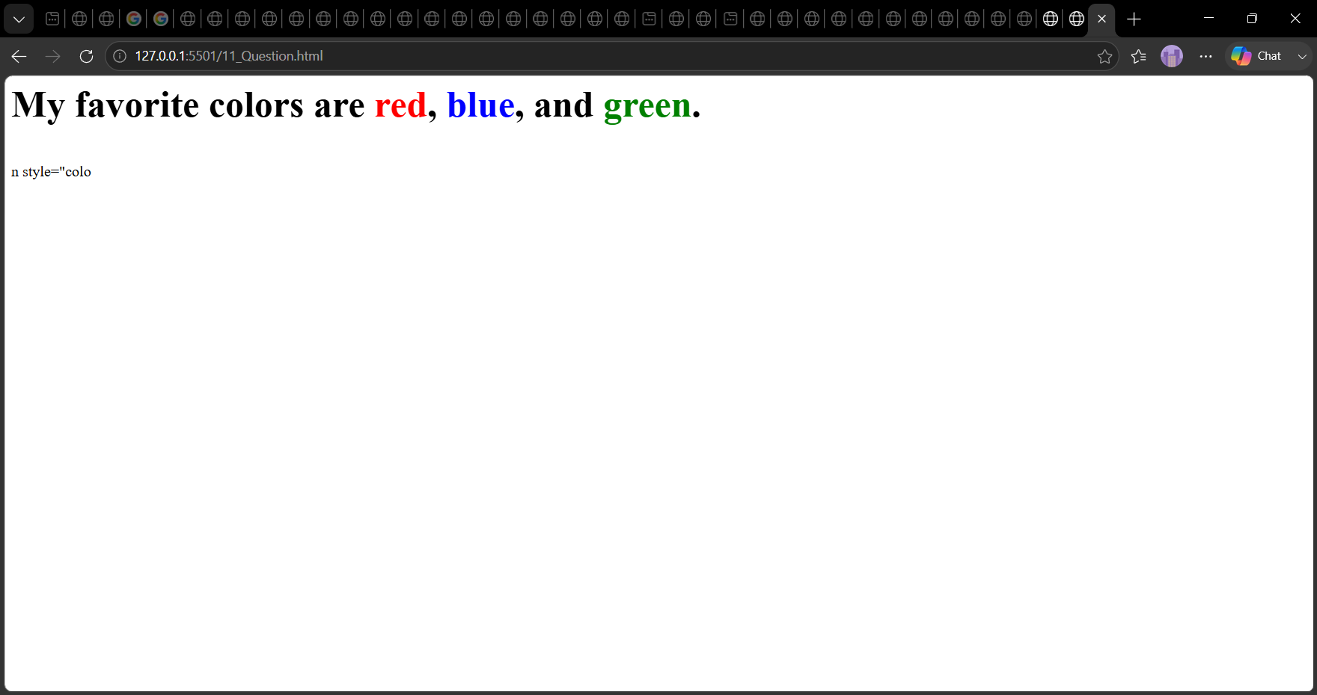

➢12. Create a creative paragraph combining multiple inline elements (<strong>, <em>,<mark>, <small>, <br>) to demonstrate inline formatting ?
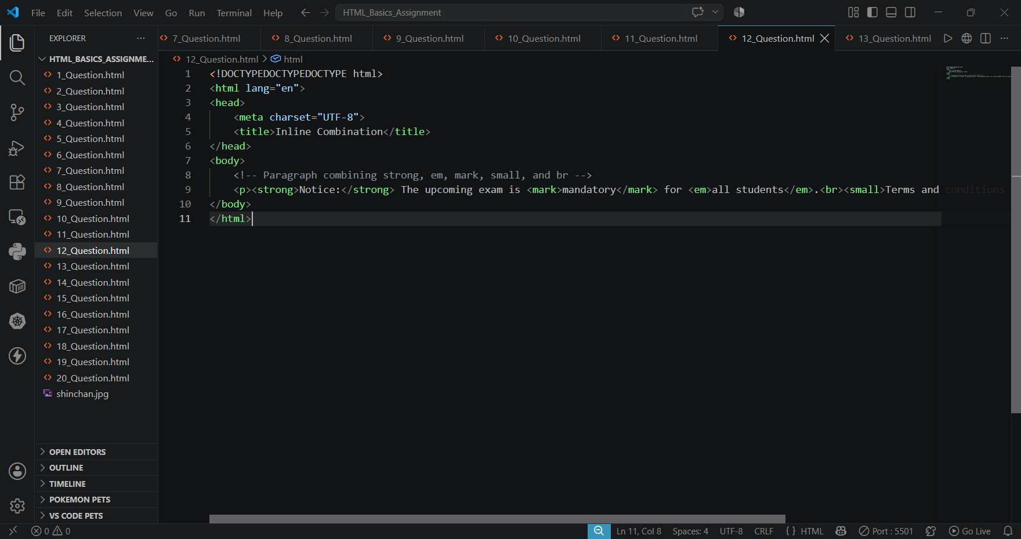

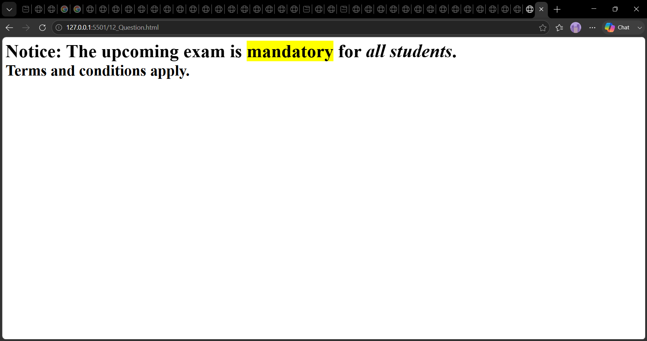
➢13. Build a small webpage with a <header> section that displays your website name or title using an <h1> tag ?
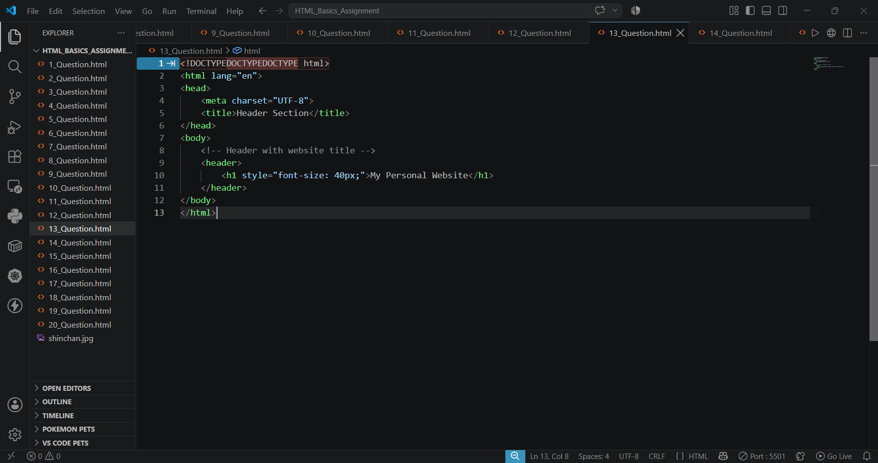

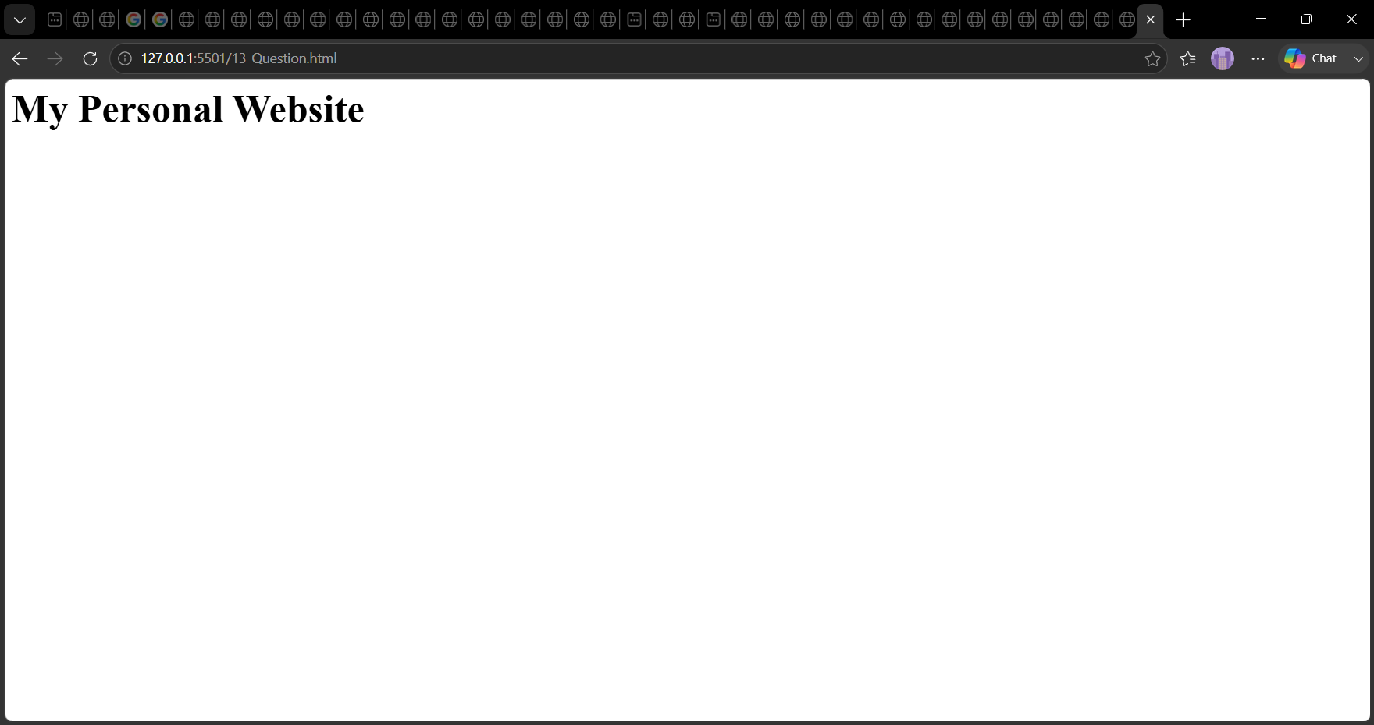

➢14. Just below the header, create a <nav> section containing three links — Home, About, and Contact. Links can use # as placeholders ?
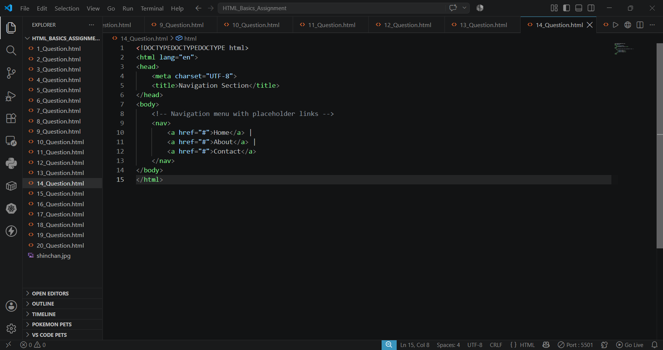

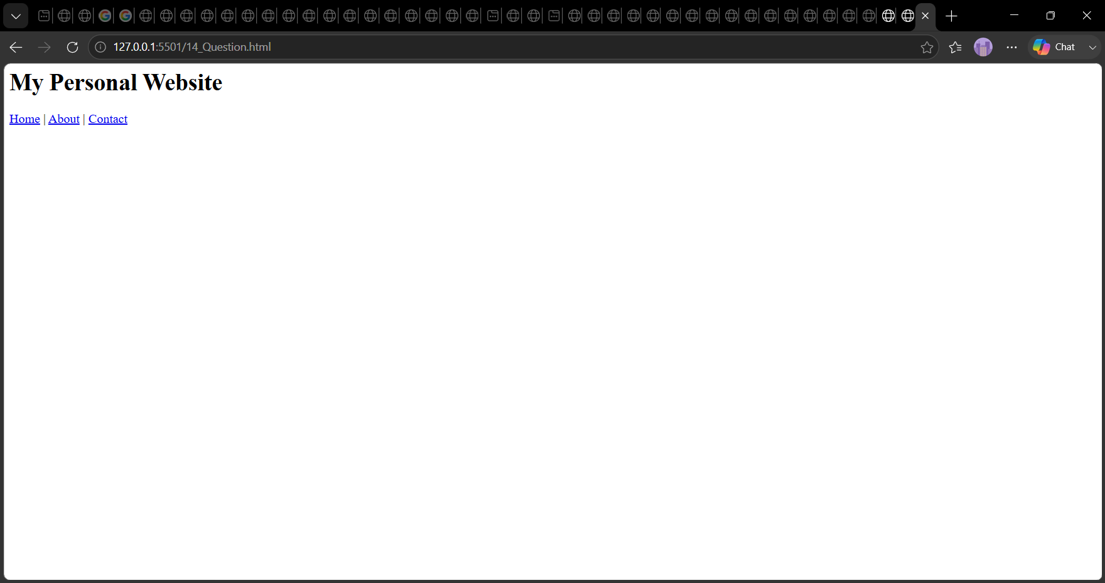

➢15. Create a <main> section containing one short paragraph introducing who you are and what the page is about ?
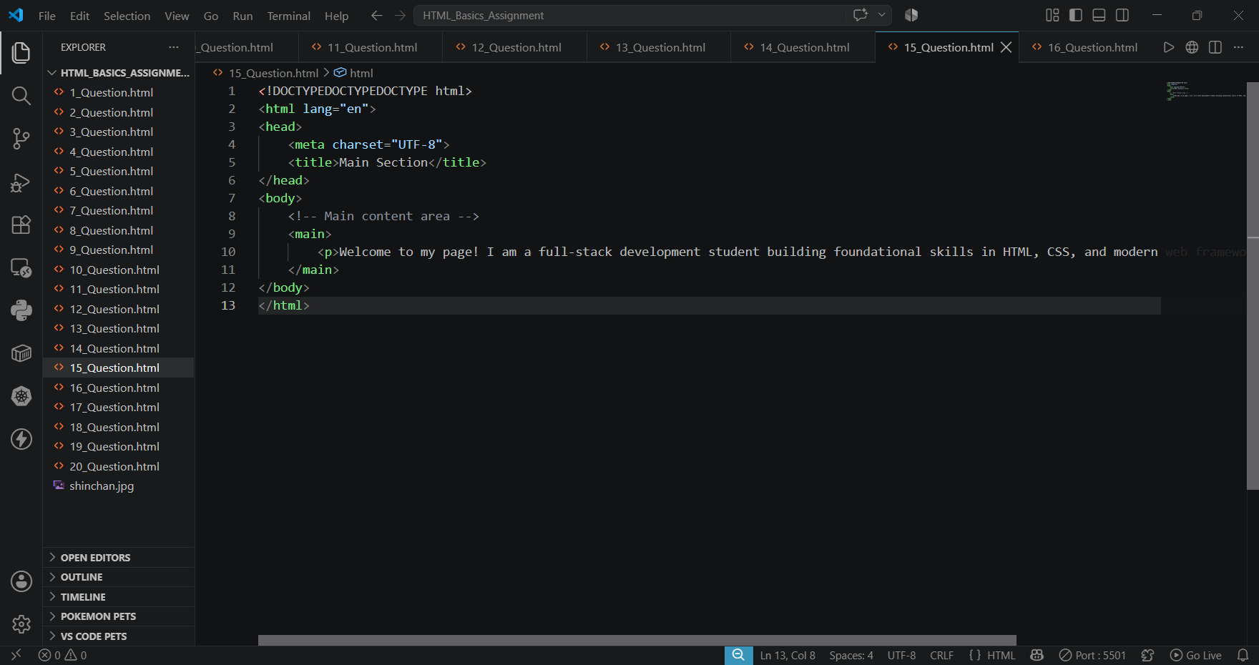

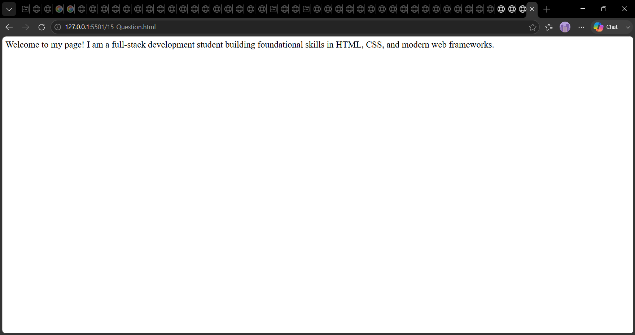

➢16. Inside <main>, create a <section> titled About Me, with one descriptive paragraph ?
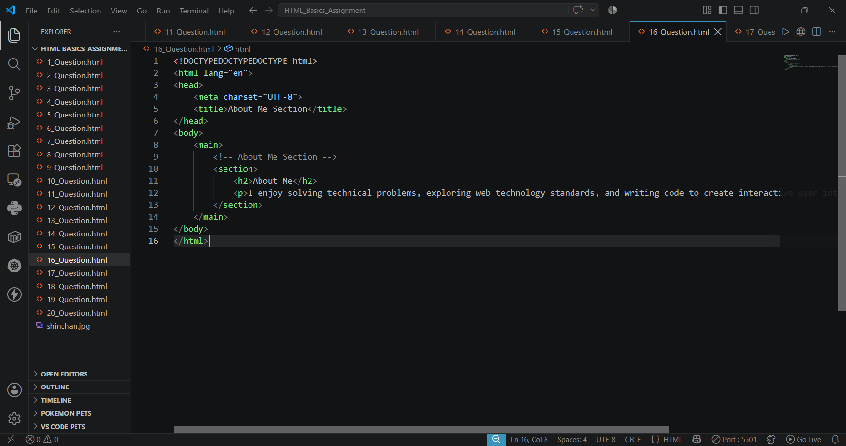

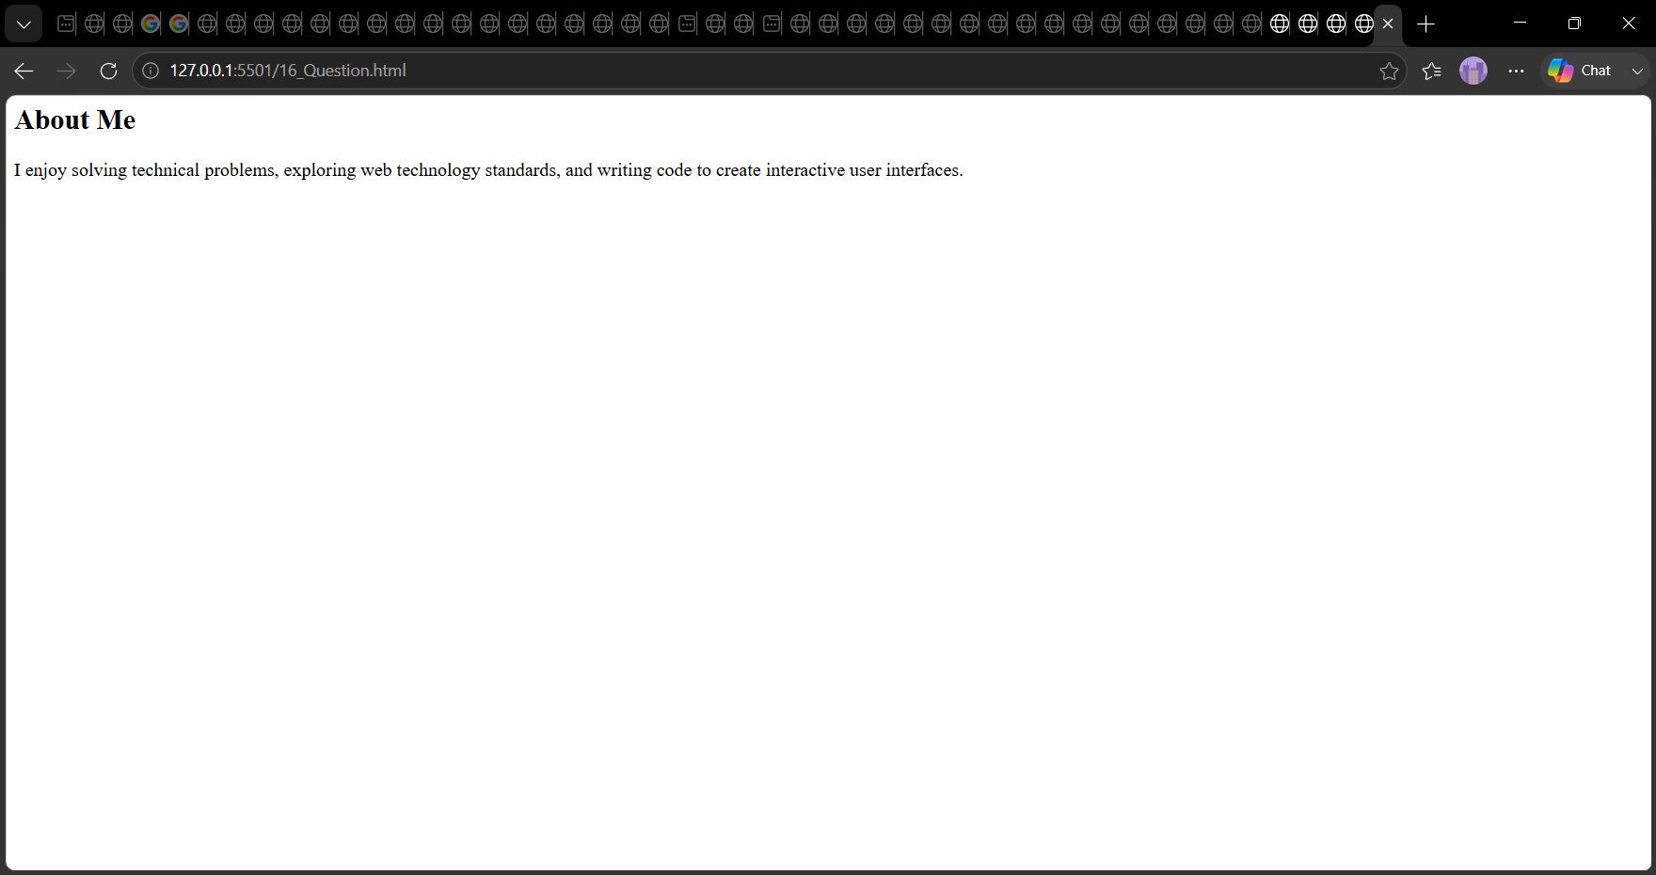

➢17. Still inside <main>, add an <article> with a heading “My First Blog” and a short blog-style paragraph ?
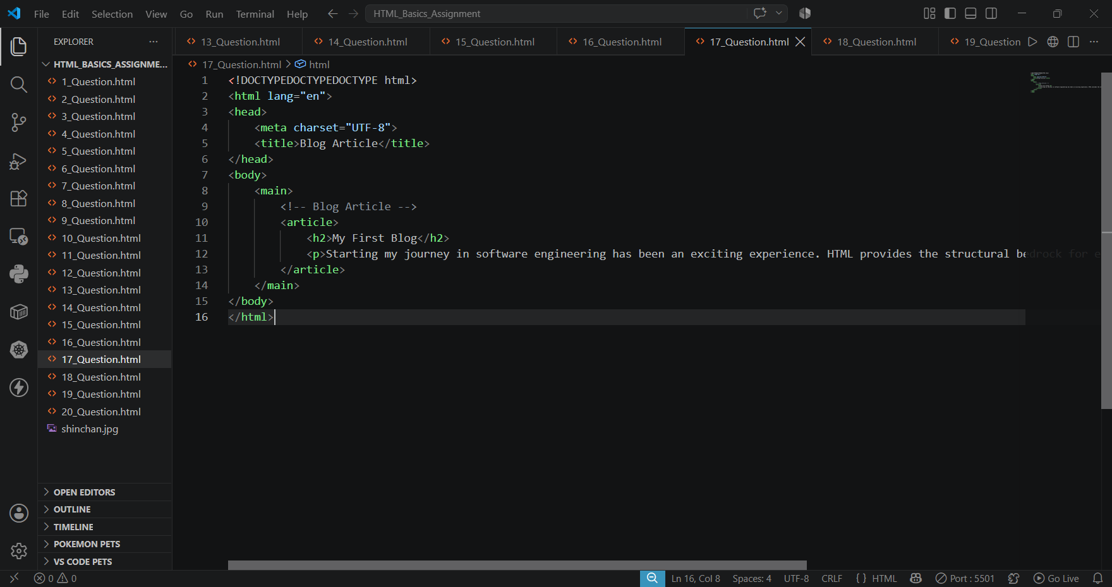

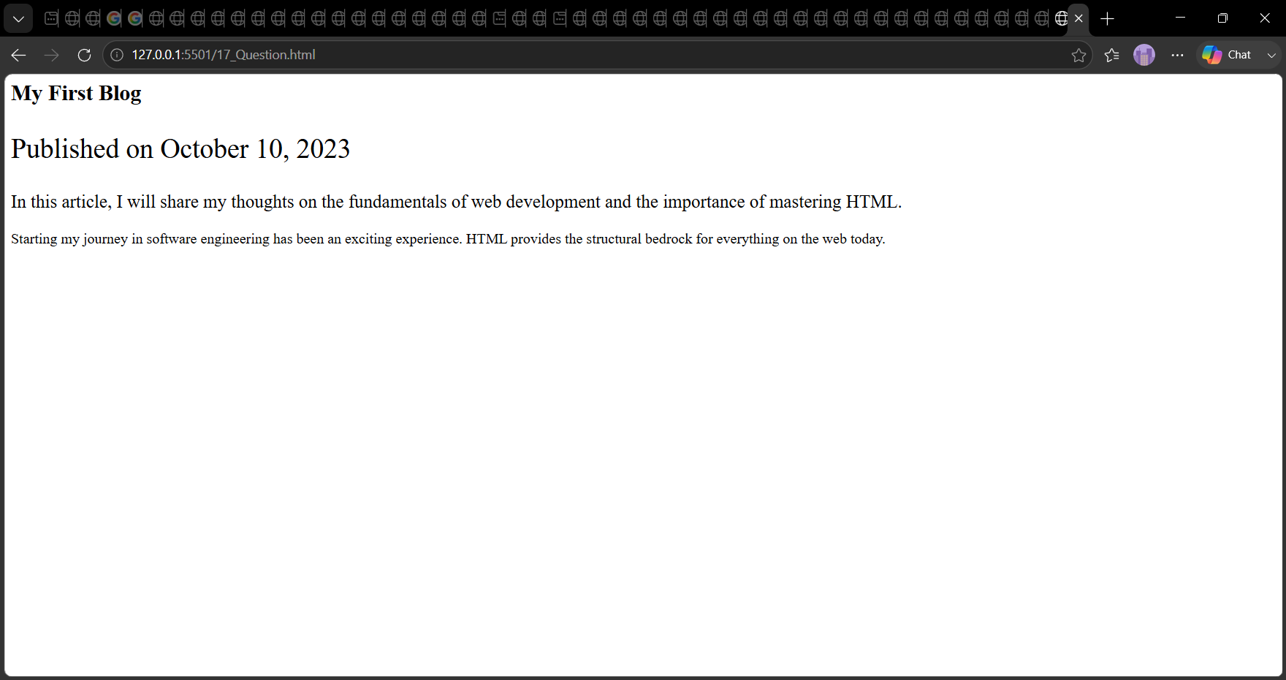

➢18. Add an <aside> element titled “Useful Links”. Inside it, include one or two hyperlinks (for example, your portfolio or favorite websites) ?
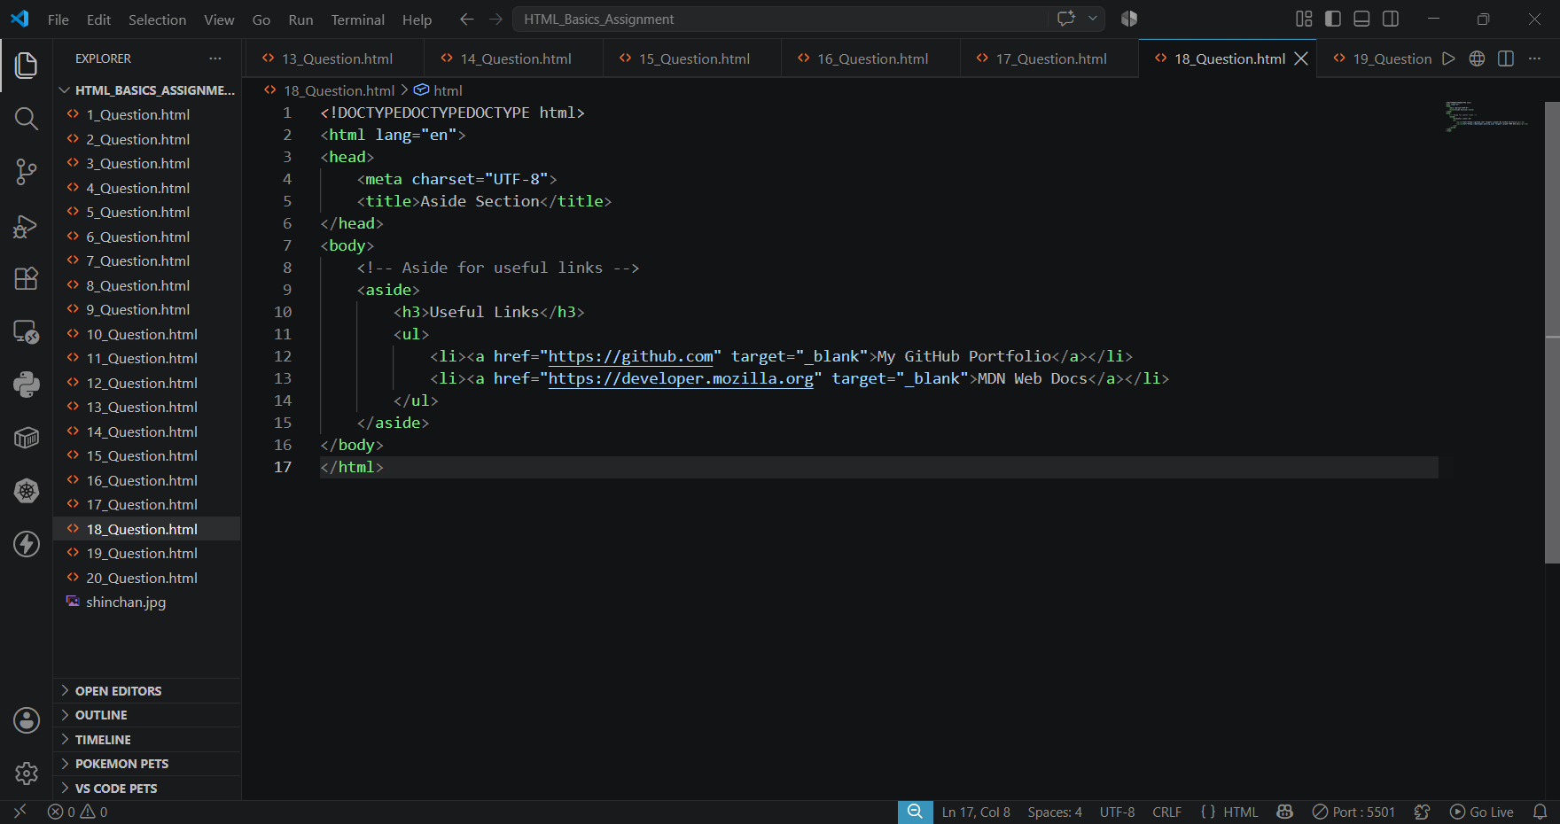

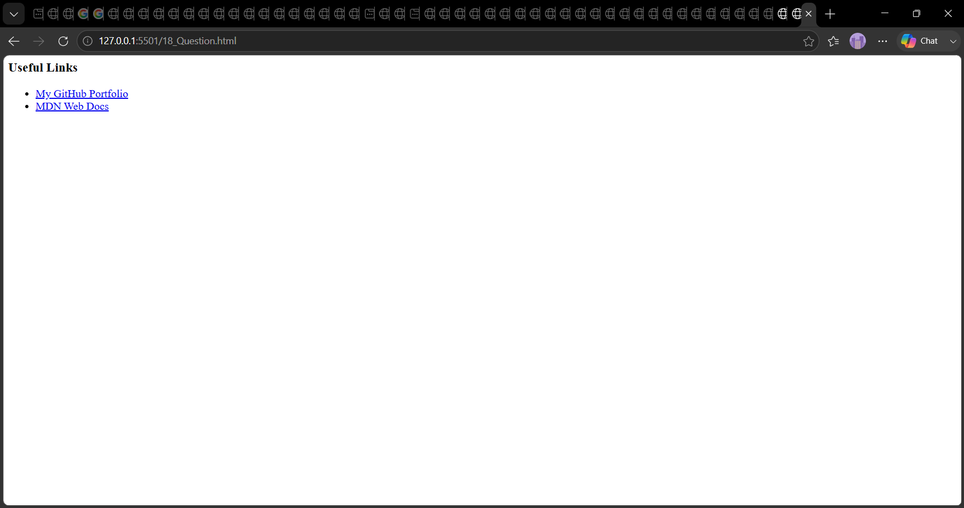

➢19. At the bottom of the page, create a <footer> that includes copyright information (e.g., ©2025 [Your Name]) ?
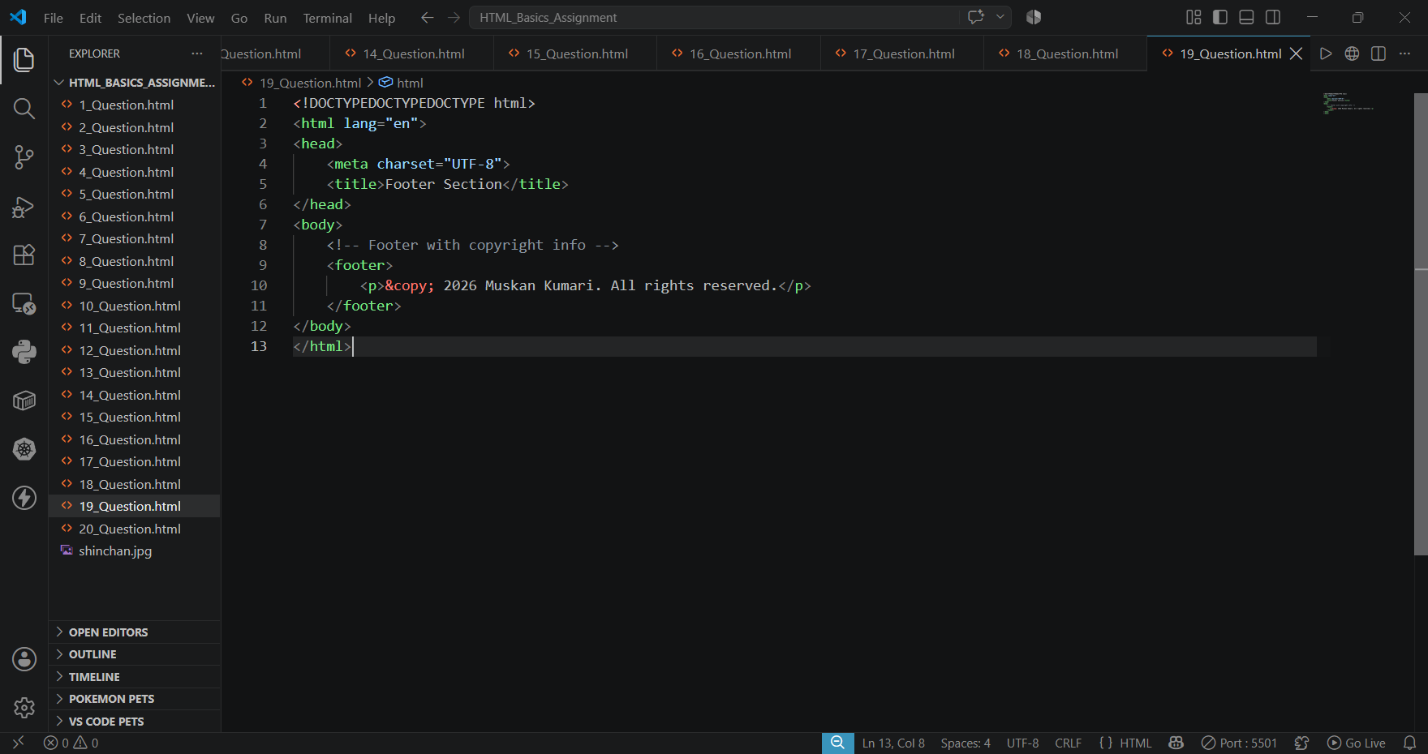

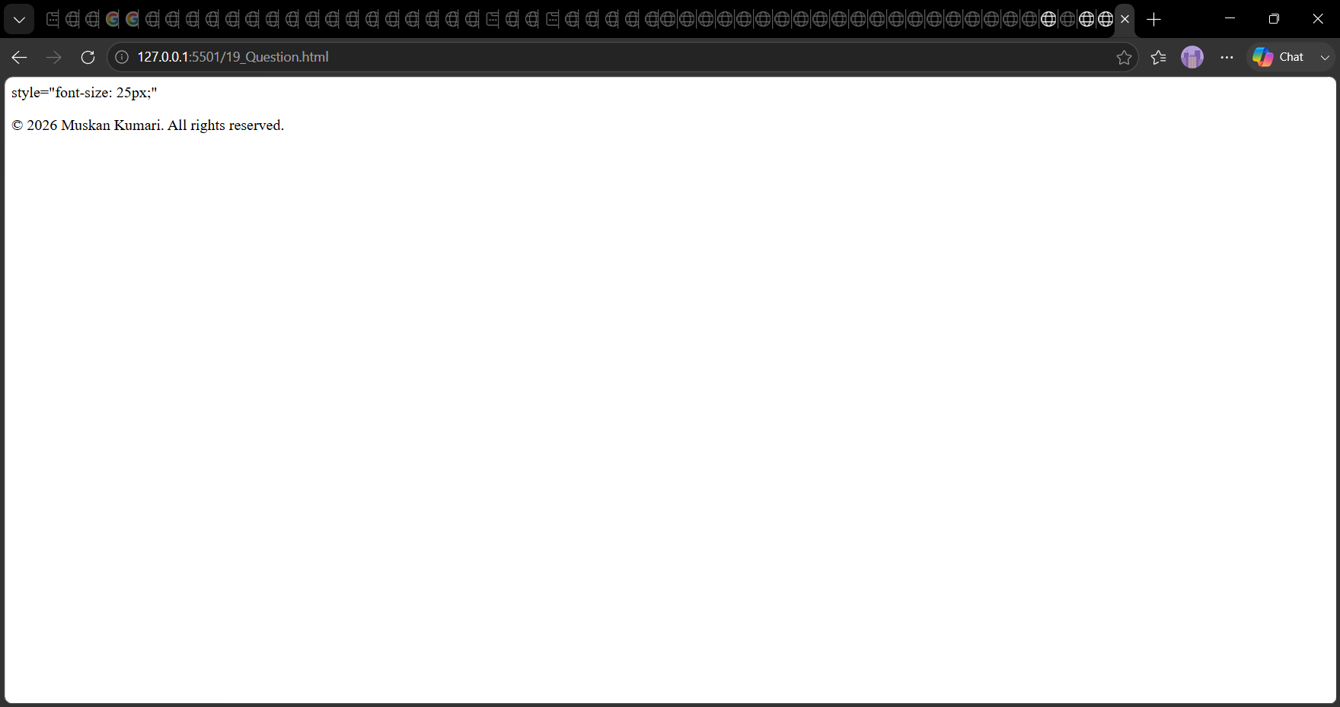

➢20. Combine all the above structure into one complete webpage — use <header>, <nav>,<main>, <section>, <article>, <aside>, and <footer> ?
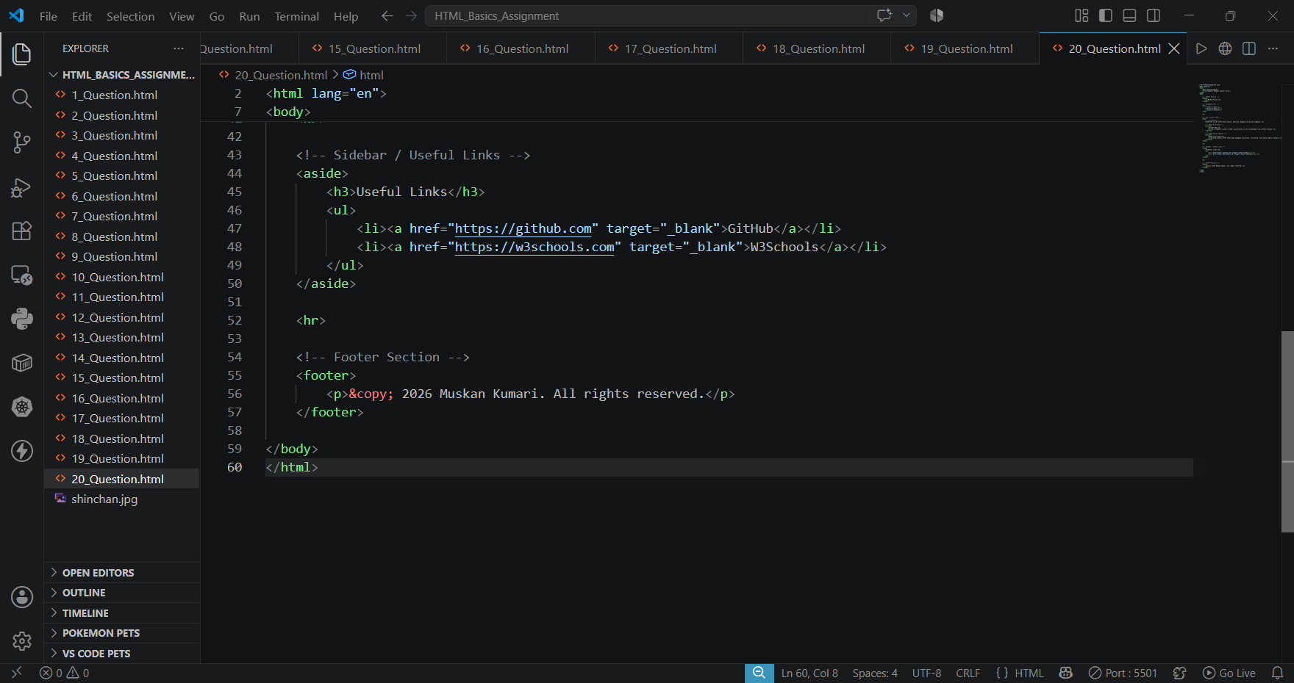

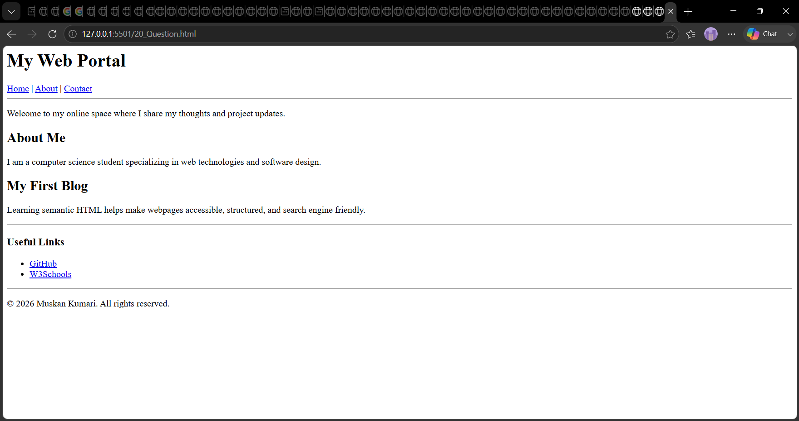
Muskan kumari [SD] 38. END

